**Front-End UI/UX Mini Project**

**Project report**

**EVENT REGISTRATION PAGE**

• Submitted By:

o Team Members- A.Raghavendra bhanu teja ,Sharon Cheriyan, Sreedev Binoj

o Register Number- 2462014 ,2462146 , 2462152

o College-E-mail id-

• Course: UI/UX Developer

• Instructor Name: MS.NAGAVEENA

• Institution: Christ University

• Date of Submission: 13/08/2025

### **Abstract**

The Event Registration Page is a responsive web application designed to allow users to sign up for an event. Developed using HTML and CSS, the project focuses on a clean, user-friendly design and modern aesthetics. The page serves as an efficient tool for event organizers to collect attendee information, providing a simple and intuitive experience for potential participants. It includes a form with various input fields such as name, email, and event selection, and is designed for performance optimization and easy navigation across devices.

### Objectives

The primary objectives of this project are to create an aesthetically pleasing and functional event registration page.

* **Professional Branding:** To design an online presence that reflects the event’s professional identity.
* **Centralized Information:** To consolidate all necessary registration fields in one accessible location.
* **Client Engagement:** To encourage potential attendees to register through a clear call-to-action.
* **Responsive Design:** To ensure the page is accessible and visually consistent on desktops, laptops, tablets, and smartphones.
* **Ease of Navigation:** To organize content into a distinct, easy-to-follow form.
* **Optimized Performance:** To use clean, minimal code for faster load times.
* **Scalability:** To design a structure that allows for future enhancements without a major overhaul.

### Scope of the Project:

The scope of the Event Registration Page includes:

* **Static Website Development** using HTML5 and CSS3.
* **Responsive Web Design** to adapt to various screen sizes.
* **Registration Form Sections**:
  + **Header**: Displays the event name and logo.
  + **Form fields**: Inputs for name, email, phone, and number of attendees.
  + **Dropdown**: A selection for different event types.
  + **Submit Button**: A clear call-to-action button.
* **Custom CSS Styling** for a consistent and modern theme.
* **Scalability** for adding future enhancements.

**Out of scope:**

* Server-side processing
* CMS integration
* E-commerce functionality

### Tools & Technologies Used

| Tool/Technolog | Purpose |
| --- | --- |
| HTML5 - | Markup and content structure |
| CSS3 - | Styling and layout management |
| VS Code - | Code editor |
| Chrome DevTools | -Testing and debugging |

### HTML Structure Overview

The HTML follows a semantic structure for accessibility and search engine optimization.

* <div class="header">: Displays the event logo and name.
* <form>: Contains all the input fields and the submit button.
* <div class="form-group">: Wraps each label and input for organized styling.
* <label>: Describes each input field.
* <input> and <select>: The form fields for user data.
* <button>: The submit button for the form.

This structure improves readability and maintainability by using meaningful tags and classes.

### CSS Styling Strategy:

The CSS uses a modular approach to separate design concerns.

* **Typography & Color Scheme**:
  + **Font**: Roboto, sans-serif for readability.
  + **Background**: A background image with a semi-transparent overlay for a modern look.
  + **Text color**: #333 for strong contrast.
* **Layout**:
  + max-width: 500px for the container to ensure comfortable reading width.
  + Flexbox is used to center the container on the page.
* **Interactive Elements**:
  + Hover effects on the submit button (

transform: translateY(-2px)) for a dynamic feel.

* **Consistency**:
  + Uniform padding and margins across sections.
  + Rounded corners (

border-radius: 10px) for a modern aesthetic.

### Key Features

One of the standout aspects of this project is its

**responsive design**, ensuring the form maintains a professional and visually appealing layout across all devices, from desktop monitors to smartphones. By using flexible layouts and CSS techniques, the website adapts seamlessly to varying screen sizes without compromising readability or functionality. This responsiveness is essential for a modern audience, allowing potential attendees to register conveniently on the device of their choice.

Another significant feature is the **consistent branding**. A logo and event name are prominently displayed at the top, reinforcing the event's professional image. A carefully selected color palette, clean typography, and balanced spacing ensure that the page is visually cohesive, creating a memorable impression for registrants.

### Challenges Faced & Solutions

* **Maintaining Responsive Layout Across Devices:** Designing a single layout that adapts to different screen sizes required careful CSS configuration to ensure all form fields were legible and well-aligned.
* **Optimizing Image Load Speed:** A high-quality background image can be large, potentially slowing down page loading. The solution involved using an optimized image and ensuring the styling was efficient.
* **Balancing Design and Content Density:** The goal was to avoid a cluttered layout while including all necessary registration fields. This was achieved by organizing fields into clear form-group sections.
* **Cross-Browser Styling Consistency:** Some CSS properties behaved differently across browsers, requiring testing and adjustments to ensure a consistent experience.
* **Ensuring Accessibility:** Making sure text contrasts were high enough and form elements were correctly labeled for users with disabilities was a key consideration.

### Outcome

The final outcome is a professionally styled, responsive registration page that:

* Clearly represents the event's brand.
* Offers an engaging user experience.
* Functions seamlessly on desktops, tablets, and smartphones.
* Loads quickly due to optimized static resources.

### Future Enhancements

* **Dynamic Event Selection:** Implement JavaScript to show or hide specific fields based on the event selected (e.g., a field for workshop preference).
* **Confirmation Message/Page:** Add a functional confirmation page or message after successful submission.
* **Database Integration:** Connect the form to a database to store registration data.
* **Email Confirmation:** Send an automated email to the user upon successful registration.
* **Animated Section Transitions:** Enhance the user experience by adding smooth animations as users interact with the page.

### References

* L&T LMS

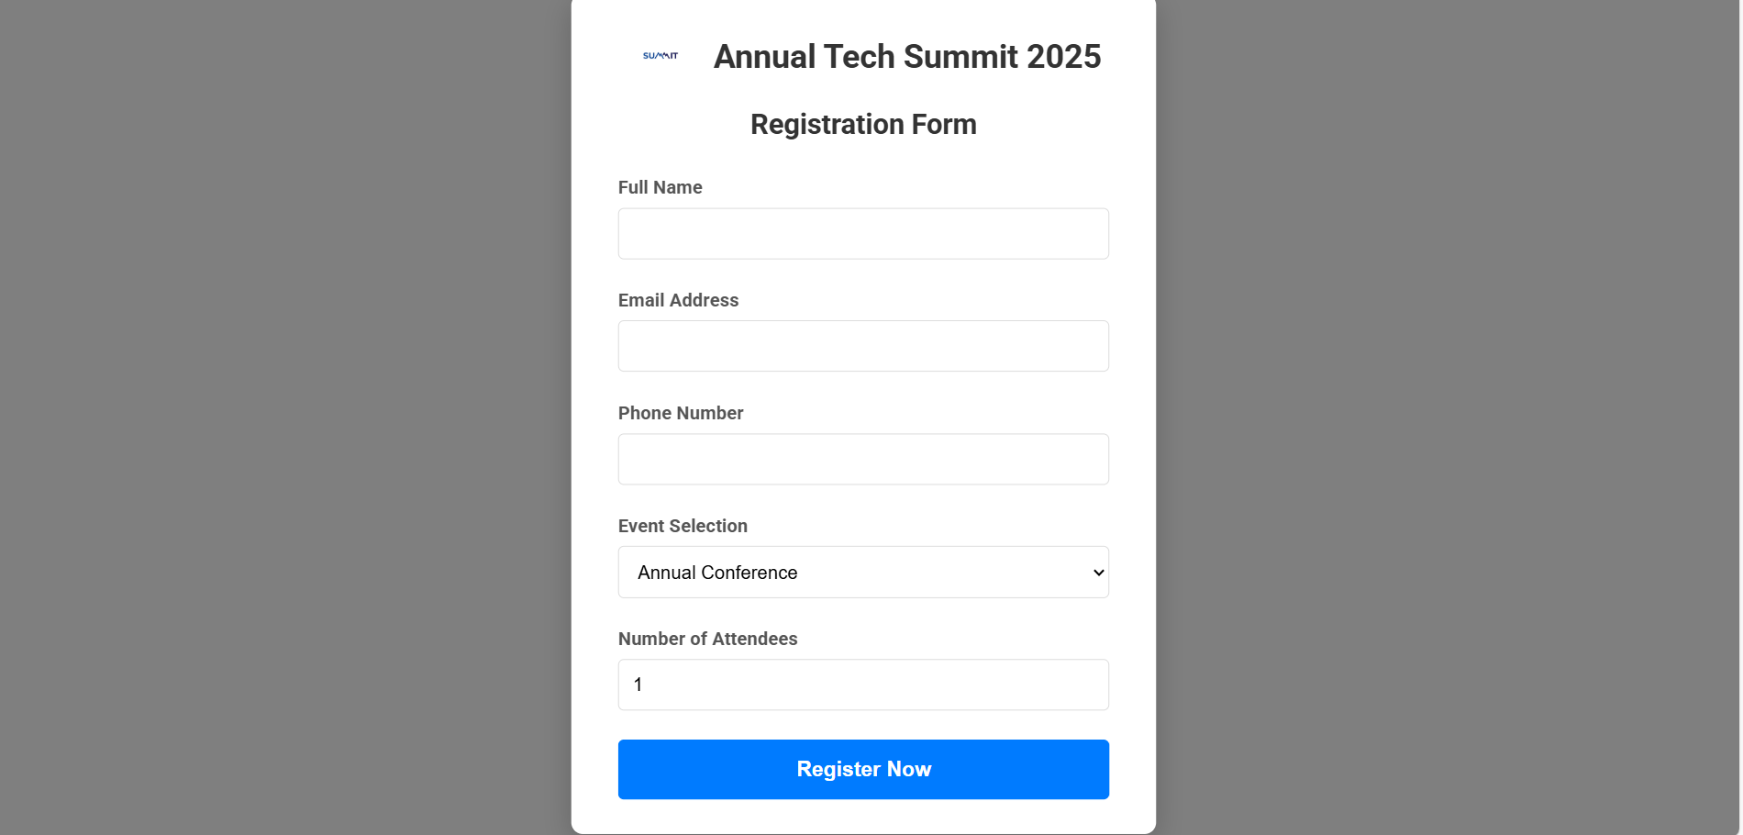

SAMPLE CODE:

<div class="container">

        <div class="header">

            <img src="logo.png" alt="Company Logo" class="logo">

            <h1>Annual Tech Summit 2025</h1>

        </div>

        <form action="#" method="post">

            <h2 class="form-title">Registration Form</h2>

            <div class="form-group">

                <label for="name">Full Name</label>

                <input type="text" id="name" name="name" required>

            </div>

            <div class="form-group">

                <label for="email">Email Address</label>

                <input type="email" id="email" name="email" required>

            </div>

            <div class="form-group">

                <label for="phone">Phone Number</label>

                <input type="tel" id="phone" name="phone">

            </div>

            <div class="form-group">

                <label for="event">Event Selection</label>

                <select id="event" name="event">

                    <option value="conference">Annual Conference</option>

                    <option value="workshop">Interactive Workshop</option>

                    <option value="webinar">Webinar Series</option>

                </select>

            </div>

            <div class="form-group">

                <label for="attendees">Number of Attendees</label>

                <input type="number" id="attendees" name="attendees" min="1" value="1">

            </div>

            <button type="submit" class="submit-btn">Register Now</button>

        </form>

    </div>